FB08 -

Functionality
The previously entered GL document was entered incorrectly. Need to reverse the document.

Scenario
A user made a mistake during document entry. Now he wants to reverse the incorrect document and post a new document again.

Requirements
Document to be reversed cannot include already cleared items. If you want to reverse document that was already cleared, you need to reset all cleared items before posting a reversal.

Menu Path | Accounting → Financial Accounting → General Ledger → Document → Reverse → FB08 - Individual Reversal
Transaction Code | FB08

1. Double click on FB08 - Individual Reversal.
2. If you don’t know the document number, click Find documents Button .
Note: The system will display the screen where you can enter the search criteria.
3. Update the following fields:

Field Name | Field Description | Values
Fiscal year | The Fiscal year number | Example: 2003
Document type | Code identifying the method that the system uses to process the transaction | Example: SA

4. Click Execute Button
5. The system will display a list of documents:

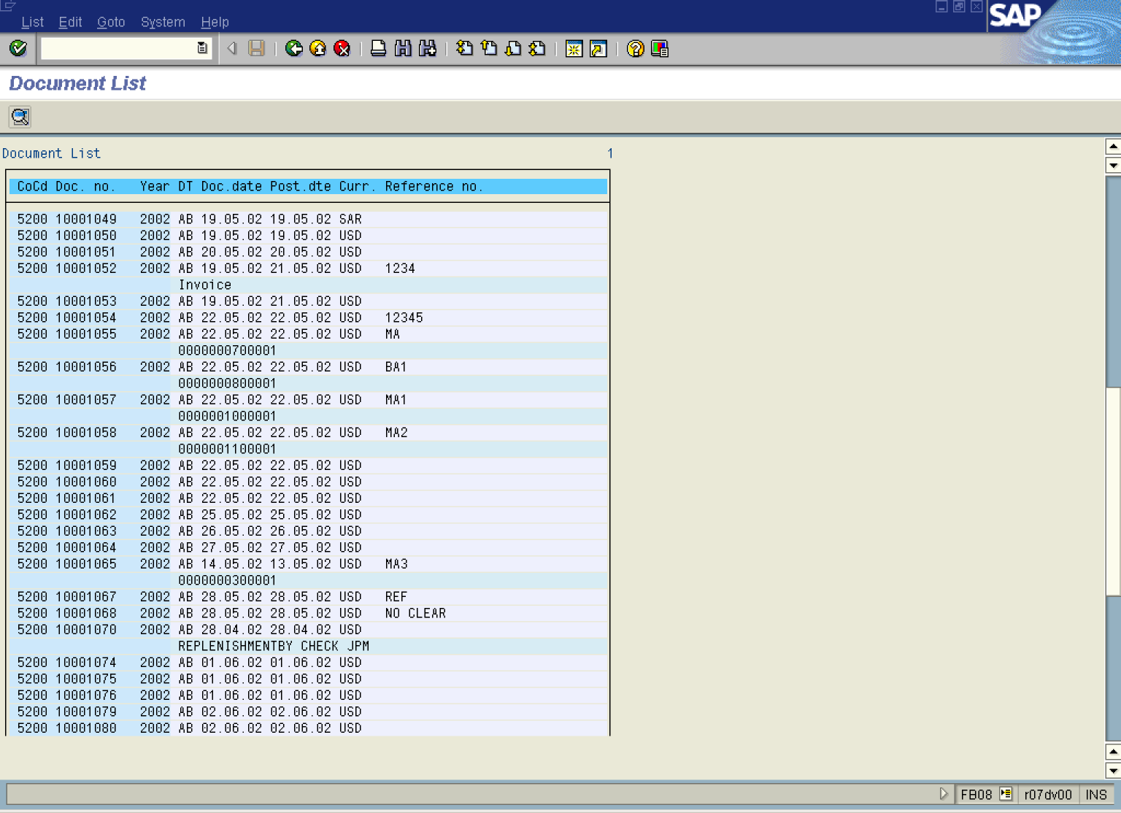

6. Click on the document you want to reverse:
.

Reverse Document: Header Data

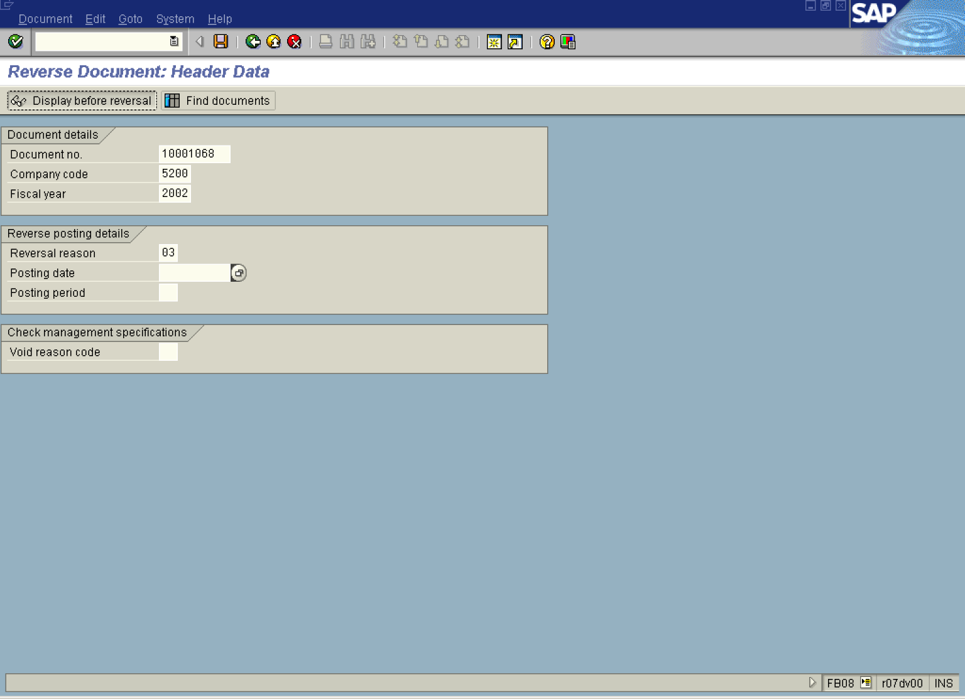

7. Update the following fields:

Field Name | Field Description | Values
Reversal reason | Type of the reversal | Example: 03

There are defined five reversal reasons:
01 Reversal in current period
02 Reversal in closed period
03 Actual reversal in current period
04 Actual reversal in closed period
05 Accrual/deferral posting
Reasons 03 and 04 allow “negative” postings. To post a negative reversal, the following prerequisites must be fulfilled:

- The company code must be defined as allowing negative postings,
- The document type must allow negative postings.

8. If you want to display the document before reversal, click Display before reversal Button .

Display Document: Overview

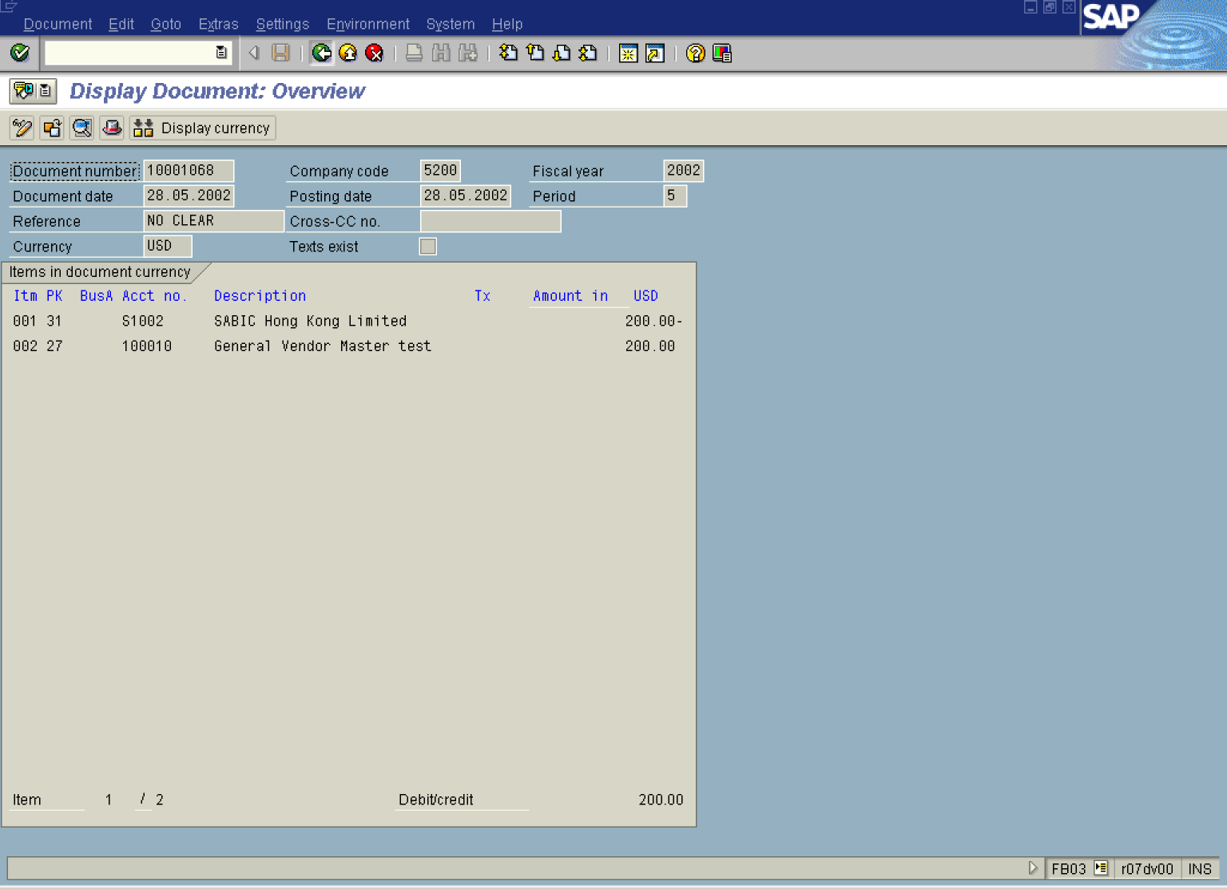

9. Click Back

Reverse Document: Header Data

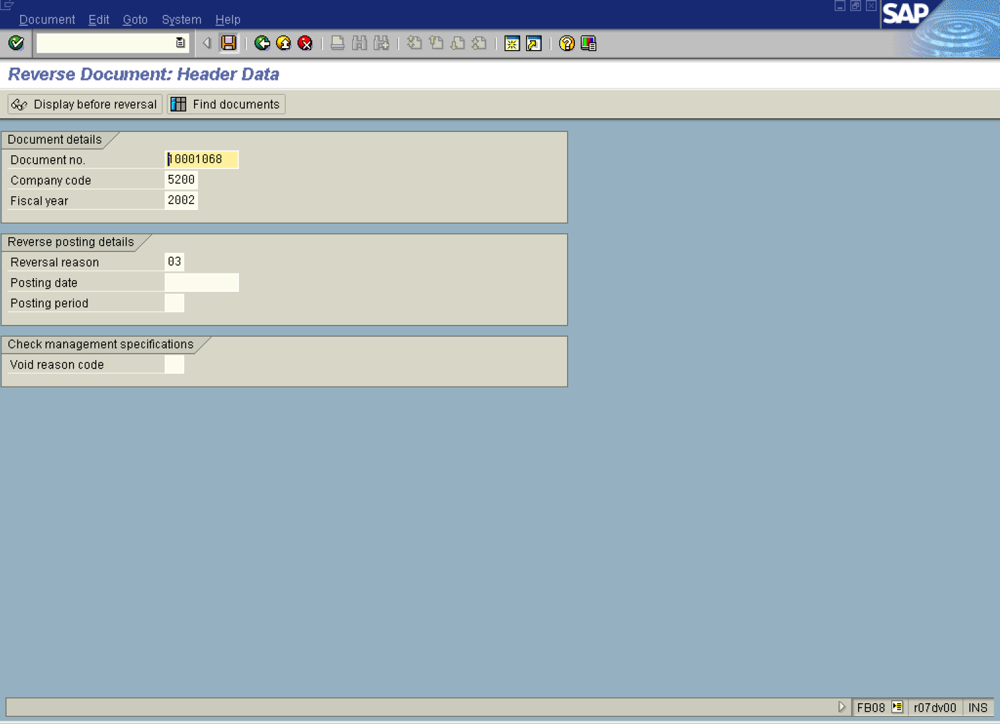

10. If you want to reverse the document, click Save Button.. The system will post a reversal document

 Depending on the configuration, a reversal document can be the same type of a document or a different one.

Another way to reverse a document is to post a new document using a negative posting option. This option is different than the regular document reversal – you can hide the line items when you analyze the account. You can also find the negative posting option useful when you posted a document containing several line items and you need to reverse only one of them. In such case it might be easier to post an additional document using the negative posting then reverse the whole document and post it again with the correct figures.

11. The message bar displays “Document XXXXXX was posted in company code 5200”.

